Beeches Pool and Fitness Centre

NOrmal Operating Procedure

anD

eMERGENCY ACTION PLAN

EDITION
19
April 2008

© Written by Sue Robinson

Edited by Sue Robinson

Beeches Pool & Fitness Centre

Beeches Road

Great Barr

Birmingham

B42 2HQ

No. (0121) 464 6296 Fax No. (0121) 464 0849

E-mail: Beeches_pool_&_Fitness@birmingham.gov.uk

Introduction to the NOP and EAP

The Normal Operating Procedure (N.O.P) and Emergency Action Plan (E.A.P) are to be used by all employees and by any organisation making use of the facilities at Beeches Pool & Fitness Centre.

Any aspect of the Normal Operating Procedure and the Emergency Action Plan can be discussed with your line manager at any time.

If any member of staff disagrees with any part of the Normal Operating Procedure and the Emergency Action Plan they must notify their line manager in writing. I will respond to your query within seven days.

If alterations are to be made, it is the responsibility of the Centre Manager to ensure that the master copies are updated and that the new copies of the Normal Operating Procedure and the Emergency Action Plan are distributed as necessary, and that any training required is made available.

Issue Date: Edition 19: April 2008

Review Period: 1st April 2008 –1 April 2009

Next Issue: Edition 19: April 2008

Centre Manager’s Authorisation:
……………………………………….

Sue Robinson – Centre Manager

This Normal Operating Procedure (N.O.P) and Emergency Action Plan (E.A.P.) has been authorised by the Area Manager.

District Manager’s Authorisation:
…..…………………………………..

Rachel Gomm – Perry Barr District Sport and Leisure Manager

CONTENTS – NORMAL OPERATING PROCEDURE
PAGE NO’S:
Contact & Address Details..…………………………………………….1
Introduction………….……………………………………………………2
Contents – NOP………………………………………………………….3
Contents – EAP………………………………………………………….4
List of Amendments……………………………………………………..5

SECTION 1 – GENERAL:
1.0 Building Plan...…………………………………………………..7
2.0 Dealing with the Public…………………………………………9
3.0 Staff Protocols.………………………………………………….10
4.0 Staff Sickness…………………………………………………...10
5.0 Cleanliness……………………………………………………… 10
6.0 Risk Assessments etc…………………………………………. 11
7.0 Phone Lines……………………………………………………..11
8.0 Lost Property……………………………………………………11
9.0 Conditions of Hire………………………………………………11
10.0 Review Date (NOP)…………………………………………….11

SECTION 2 – WET SIDE:
11.0 Staffing Levels/Pool Dimensions….………………………….. 12
12.0 Responsibilities of Staff (Plans)…………………………….…14
13.0 Maximum Bather Loads………………………………………..15
14.0 Potential Risk Factors………………………………………….15
15.0 Swimwear Guidelines………………………………………….16
16.0 Staff Qualifications……………………………………………..17
17.0 Staff Training……………………………………………………17
18.0 Systems of Work……………………………………………….18
19.0 Call out Procedures……………………………………………19
20.0 Pool Incident Alarm …………………………………………….19
21.0 Swimming Instruction………………………………………….. 20
22.0 Foreign Matter in the Water……………………………………21
23.0 Spinal Injury Management……………………………….…….22
24.0 Lockers…………………………………………………………..23
25.0 Special Needs Pool Chair & Hoist…………………………….23
26.0 The boat & See-Saw Inflatable………………………………..24

SECTION 3 – DRY SIDE

27.0 Sauna and Steam ………………………………………………27
28.0 Sun beds………………………………………………………….28
29.0 Gym Instructors and Fitness Suite ……………………………28

CONTENTS – EMERGENCY ACTION PLAN

PAGE NO’S:

SECTION 1 - GENERAL:
1.0 Plan of Emergency Equipment………………………………..29
2.0 Fire Procedures…………………………………………………30
3.0 Bomb Procedures……………………………………………… 34
4.0 Emission of Toxic Gases /Substances………………………. 36
5.0 Structural Failure………………………………………………..36
6.0 Lighting Failure…………………………………………………. 36
7.0 Disorderly Behaviour (Including Violence to Staff)…………. 37
8.0 Physical Assault………………………………………………...38
9.0 Raid on Reception.……………………………………………..38
10.0 Sexual Assault………………………………………………….38
11.0 Reception Emergency.…………………………………….…...38
12.0 Chemical Usage Procedure……………………………………38
13.0 Lost and Found Children Procedure…………………………. 39
14.0 Special Need Toilet Alarms …………………………………...39
15.0 First Aid Incidents/Needlestick Injury………………………… 39
16.0 Accident Reporting…………………………………………….. 40
17.0 Review Date (EAP)……………………………………………..40

SECTION 2 – WET SIDE

18.0 Wet Side Emergency Equipment……...………………………41
19.0 Rescue and Pool Procedures………………………………… 42
20.0 Overcrowding……………………………………………………44
21.0 Lack of Water Clarity……………………………………………44
22.0 Accidents Involving Pool Outlets and Grills…………………..44
23.0 Spinal Injuries……………………………………………………44

List of Amendments

This section will show you any amendments to this edition from the last edition.

Subject Brief Description Page No. Section

NOP Dealing with the public 9 2.4
Phone Lines 11 7.2
Review Procedure 11 10.1
Potential Risk Factors 15 14.5
Staff Training 17 17.5
Staff Training 17 17.6
Inflatables 24 26.0

EAP SLA’S & Pool Plant room Operators 33 2.4.5

NORMAL OPERATING PROCEDURE
GENERAL
Section
1

- BUILDING PLAN

Ground Floor Plan

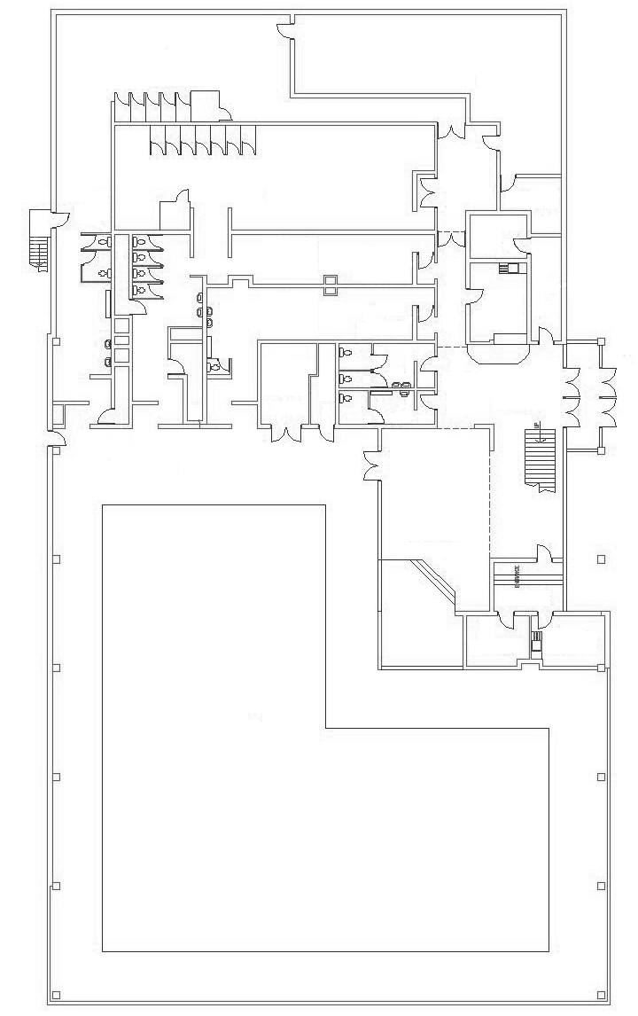
Pool
Entrance
Gym
Male Changing
Female changing
Girls changing
Boys changing
Float
stores
Reception
Café
Area

Staff rooms
Shallow end
0.6
0.9
0.9
1.3
1.8
Deep End
Main office
Key

Fire exits

Fire extinguishers

Fire Alarms

Drowning alarm

First Floor Plan

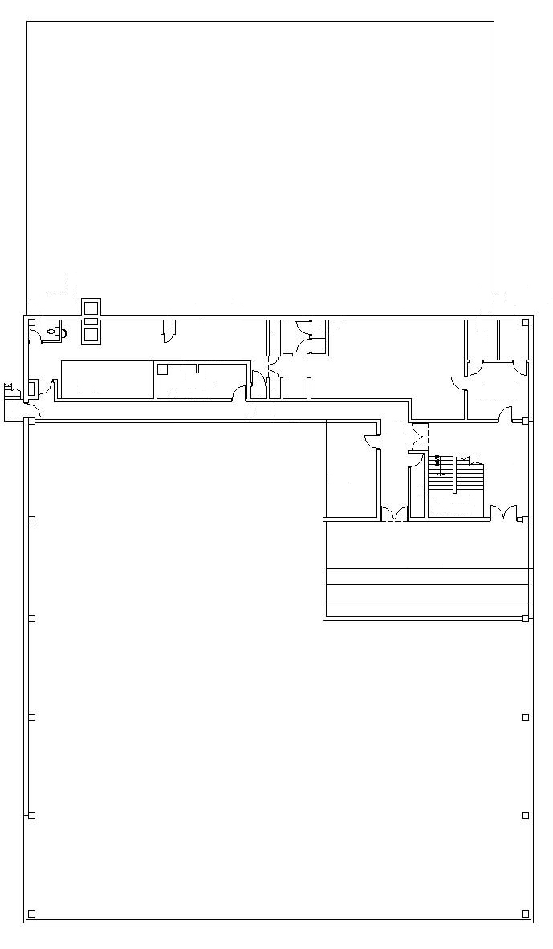
Pool
Roof Space
Sauna
Steam
Sun beds
Key

Fire exits

Fire extinguishers

Fire Alarms

Emergency alarm

Basement Plan

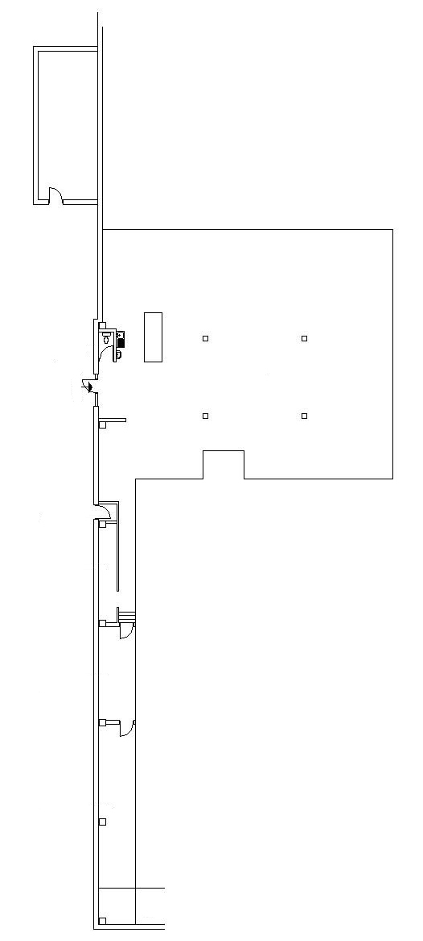
Key

Fire exits

Fire extinguishers

Fire Alarms

Emergency alarm

Fire Exit
1 2 3
Filters
Inflation pumps
Toilet
Air handling changing rooms
Plate heat exchanger
Boilers
Air handling pool unit
Circulation pumps
Dosing system
& dulco

2.0 DEALING WITH THE PUBLIC

2.1 All staff on duty should be polite, helpful and converse with the Customer Charter Standards.

2.2 Staff must encourage safe and enjoyable use of the facility and activities. Discourage any individual or group behaviour that may spoil other user’s enjoyment or create dangerous situations for themselves or others. Draw attention to public safety notices.

2.3 Customers must be advised to use the coin operated lockers for the safety of their personal belongings, and advised to keep their key on them at all times whilst using the pool.

2.4 Any swimmer seen attempting to enter the facility whilst under the influence of drink or drugs must be prevented form doing so. Staff must also advise customers that they must not eat food a minimum of 1 hour before swimming.

2.5 The Duty Manager may refuse admission to any person felt to pose a danger to themselves or others. Anyone putting themselves or other customers at risk will be asked to leave the premises.

  - All children aged under eight, or appearing to be under eight, must be accompanied at all times – in and out of the water – by a responsible adult aged over sixteen. Maximum of two under eights per adult.

2.7 User Group Characteristic:

Safety of people with special needs to be assessed on a case-by-case basis.

- There are sufficient helpers in the water to provide adequate support.
- There are a sufficient number of other helpers, such as parents and friends, available to provide additional support and assistance. This is especially important in the event of an emergency requiring the evacuation of the building.

2.8 When dealing with complaints the details should be clearly established and an apology given, the problem owned and where possible a solution offered. A proper explanation should be given whilst maintaining loyalty to the organisation.

2.9 It is the responsibility of all staff to create an atmosphere where the public feel that they can express any concerns they may have and feel the response is one of a positive nature.

2.10 If approached by a customer and you are unsure or unable to deal with their enquiry, complaint or suggestion, pass the customer onto the Duty Manager who will deal with the situation as effectively as possible.

3.0 STAFF PROTOCOLS

3.1 Staff must make every attempt to ensure that when they arrive for duty, they are on time and that their appearance is in accordance with Birmingham City Councils uniform / Personal code of practice. Staff must, at all times, ensure that their uniform is clean, neat and tidy, and is always tucked in. They must always have a name badge on.

3.2 A spare set of uniform must be kept on site while on duty, to be used as a change of uniform in the event of a water rescue.

  - Staff MUST NOT drink alcohol or take drugs before or during shifts.

3.4 Beeches Pool & Fitness Centre is a NO SMOKING building, there are no areas within the building that smoking can take place by public, a designated area is provided for staff use.

- STAFF SICKNESS

4.1 If an employee is sick or unable to work he/she must contact the site immediately if they are on the morning shift, preferably the night before. If they are on the afternoon shift, they must contact the site by 10:00am.

4.2 On contacting the site, staff must speak to the Duty Manager who will record the sickness on the appropriate forms, which are kept in the main office. It is permissible for a third party to call on your behalf but it is preferred that the staff member contacts the centre.

4.3 On your return to work you will be asked to attend a “Return to Work Interview” where you will be asked a number of questions in respect to your illness. It is permissible to take support into the interview i.e. a work colleague or union representative. If necessary, due to the nature of the illness, you can request a person of a specific sex to conduct the return to work interview.

4.4 Abuse of the sickness scheme can lead to termination of your contract of employment.

4.5 Further details on sickness management can be found in “Managing Attendance – A Guide for Employees”.

- CLEANLINESS

5.1 Employees need to ensure that high levels of Customer Standards are met.
- Floors are kept clean, are drained where necessary, and are not slippery;
- The premises are kept clean, including internal walls, ceilings, furniture and fittings;
- Appropriate containers are provided for waste products;
- Refuge and trade waste are disposed of regularly;
- Spillages are promptly cleaned up.

6.0 RISK ASSESSMENTS /C.O.S.H.H DATA HAZARD SHEETS SUBSTANCES

6.1 With all activities there is a risk; certain activities are more of a risk than others. To counteract this problem, risk assessments have been carried out on all areas and procedures with a potential risk factor. This has resulted in a risk assessment folder that details risks and the correct procedure to adopt to prevent accidents occurring. This is situated in the office.

6.2 All chemicals must be C.O.S.H.H assessed before they are allowed to be used on site. This means that they must have a data hazard sheet and the Safety Section has passed them for use. If you are unclear or require any additional information, this can be found in the substances register. Which is held in reception.

PHONE LINES

7.1 The emergency telephone on the poolside, and the public payphones in reception, may be used to make any 999 calls.

7.2 In the event that the phone lines become in operational the Duty Manager must be informed. The fault should then be reported to IT Helpdesk on 0121 464 4444 (during office hours) leisure flex 0121 464 3151 all times.

7.3 Internal telephones may be used when necessary to contact other areas of the leisure centre. To do this lift the receiver and dial the appropriate numbers corresponding to the area / person you wish to contact.

- LOST PROPERTY

8.1 All lost property is to be taken to reception and logged in accordance with the Leisure Centres Lost Property Procedure.

- CONDITIONS OF HIRE

9.1 Customers hiring a facility must be provided with a copy of the "conditions of hire” leaflet and advised to read and comply with the information supplied.

- REVIEW PROCEDURE

10.1 These procedures are under constant review. The NOP will next be issued in June 2008. If you wish to contribute to the review process please advise your line manager.

NORMAL OPERATING PROCEDURE
Section
2
WET SIDE

  - STAFFING LEVELS

  - POOL DIMENSIONS

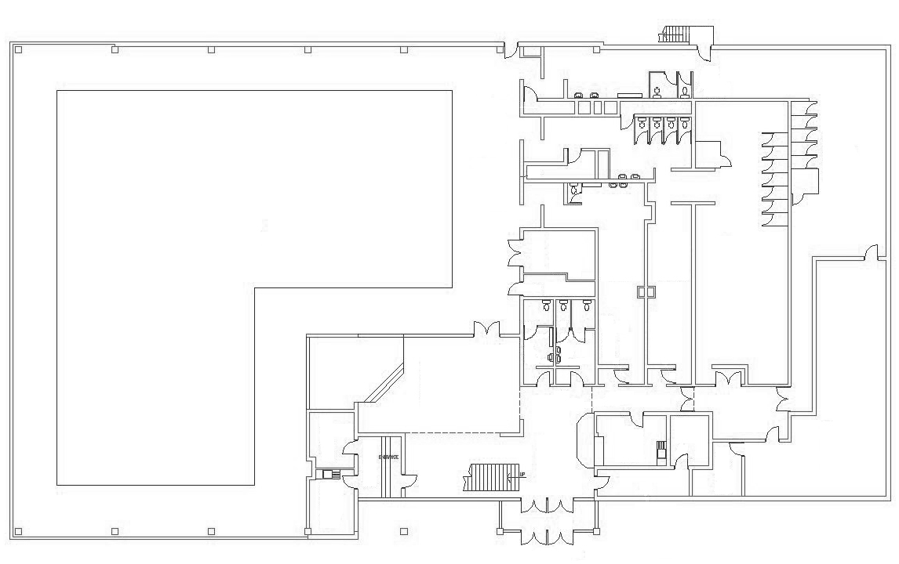
25.6m
26m
13.6m
11.9m
12.3m
13.7m

11.2 For Pool sessions:

ACTIVITY | POOL | BATHER LOAD | LIFEGUARD(S)
Sun Risers (Early Bird) | Large/Small Pool | 1 – 250 | 2
Public Session | Large/Small Pool | 1 – 250 | 2
Private Party/ Inflatable | Large/Small Pool | 1 - 250 | 3/4
Dual Use Parties | Small | 1 - 50 | 2
Splash Session/ Inflatable | Large/Small Pool | 1 - 250 | 3/4
Swimming Lessons/Public | Large/Small pool | 1 - 250 | 2
Swimming Lessons* | Large/Small Pool | N/A* | 1

Table: The number of Lifeguards may increase at the discretion of the Duty
Manager or if bather load dictates.

*Lifeguards assisting teachers, rotating and being responsible for Spectators.

11.3 If circumstances dictate, the Duty Manager may increase the number of staff on pool duty.

11.4 For inflatable sessions/pool parties, three/four lifeguards must be on pool duty in accordance with Health and Safety recommendations.

11.5 There is adequate seating for 50 people for parties; anyone wishing to take photographs or use video equipment must fill the appropriate form at reception.

11.6 For club sessions – one member of staff with relevant qualifications MUST be on duty, if the club in question provides their own lifeguard and proof of qualifications must be provided to the satisfaction of the Duty Manager. These lifeguards must sign in at reception.

11.8 For club sessions – diving will only be permitted at the designated areas of the pool, and taught by a qualified teacher.

11.9 SEE PLANS FOR POSITIONING OF LIFEGUARDS.

12.0 RESPONSIBILITIES OF STAFF AT EACH POSITION

12.1 Normal Pool Operation.

LIFEGUARD ONE – Responsible for patrolling the Large Pool. This is a mobile position.

LIFEGUARD TWO – Responsible for patrolling the Small Pool. This is a Mobile position.

LIFEGUARD THREE – Responsible for patrolling the middle section of the pool, during busy times/splash session.

NB: If the Lifeguard is the rescuer, the team will carry out individual responsibilities.

12.2 S.L.A’s must check the first aid kit, rescue equipment, incident alarms, spinal board and oxygen therapy kit daily, at the beginning of each day. (If the oxygen bottle is less then three quarters full, then you must contact Mike Rothwell or Jimmy Hackett at Wyndley on 0121 464 0336)

Lifeguard
Position 2
Lifeguard position 1
Lifeguard position 3

13.0 MAXIMUM BATHER LOAD

POOL | No.’s of Users
Large Pool  Small Pool | 200  50

13.1 The above figure is based on an even distribution of bathers throughout the pool. All S.L.A’s and L.A’s must monitor by regular head counts. If a situation arises where the number of bathers in the pool is leading to a potential risk, the Duty Manager must be notified and ticket sales suspended. The bather load must be reduced to acceptable levels.

13.2 When the bather load reaches 150 an extra lifeguard will be placed in the pool. See positioning of lifeguard three above.
14.0 POTENTIAL RISK FACTORS

14.1 Bathers should be advised when leaving the pool area in swimwear that the foyer area might become slippery when wet.

14.2 Bathers MUST be prevented from standing or walking on the walls around the poolside.

14.3 Visual contact between lifeguards may be hampered due to the pool design. It is important that lifeguards consider the visibility aspect when positioning themselves.

14.4 Extra vigilance is required during special needs sessions.

14.5 Staff MUST ensure diving only takes place from the deep end promenade of the Large Pool, not from the side promenades. Water depth must be minimum 1.5m with a reach of 7.6m. (Diving from other areas is only permitted during programmed lessons and with a qualified teacher).

14.6 Staff MUST prevent diving in the Small Pool.

14.7 Bathers should be warned about running around the pool as this area can become slippery when wet.

14.8 Bathers should be warned of the steps around the poolside.

14.9 Rafts (body boards) and smaller inflatable toys, consider:

- Falling against poolside
- Lack of vision under the raft
- Boisterous behaviour
- Stacking of rafts
- Jumping from rafts

14.10 Lifeguards should be aware of the glare on the water surface caused by southerly facing windows and the ‘L’ shape of the pool makes it important for the lifeguard to stand in the correct position for the visibility at all times.

15.0 SWIMWEAR GUIDELINES

15.1 Customers swimming in Local Services pools should wear swimwear that is Safe, Clean and respects the dignity of all customers. In the main, customers will wear normal swimming costumes that can be brought in high street shops and which should be suitable, if the following applies:

Swimming Costumes
Should offer cover through thickness of linings.

Swimming Shorts
Again, swimming shorts should offer cover through thickness of linings, be cut above the knee and be a lightweight (not denim) type of material and include a gusset.

Adaptable Clothing
Some customers may feel the need to wear adaptable clothing for a number of reasons, i.e. people being overweight, skin problem etc. The adaptable clothing must be suitable for the following main reasons:

SAFETY, DIGNITY, HYGIENE AND HEALTH

15.2 SAFETY

Adaptable clothing such as a T-shirt, leggings etc. should be: -

- Lightweight
- Relatively close fitting to avoid the danger of drag
- Not hazardous to other bathers
- Appropriate for the session attended

Jewellery should be kept to an absolute minimum and should only be allowed if it does not pose a threat to the individual wearing it or other bathers.

Where customers need to wear, or have with them, an object of religious and cultural significance then these should be assessed against the safety criteria. For example a ‘Kirpan’ (Sikh dagger) may be worn by an individual from the Sikh faith as long as it is not displayed openly and is kept under clothing or secured in a pocket of the swimwear.

15.3 DIGNITY

Adapted clothing may be worn to reduce embarrassment and satisfy individual cultural / dignity requirements, i.e. customers:

- Feel they are overweight
- Are pregnant
- Have skin impairments e.g. scar etc.
- Have religious or cultural dress codes (male and female customers)

All swimwear should offer reasonable and generally acceptable levels of cover as not to offend or embarrass other customers.

  - HYGIENE AND HEALTH

In the interest of hygiene all swimwear should be clean.

Clothing worn for an activity session immediately prior to swimming (such as T-shirts worn in a fitness class or sauna) will not be permitted.

CUSTOMER SERVICE

People wearing adapted clothing should not be challenged every time they enter the pool as this only increases their embarrassment. They should only be approached regarding their dress if it does not meet the criteria outlined in the previous sections.

Some key things to remember when dealing with any of the service issues outlined above:

Sensitivity, Politeness, Listening and respect for individual differences.

Discrimination against individuals on the basis of their gender, race, religion, culture or disability is against our policy and can be illegal.

16.0 STAFF QUALIFICATIONS

16.1 The minimum qualification for a Leisure Assistant with lifeguard responsibilities is a current RLSS National Pool Lifeguard Qualification or the STA NARS PL qualification.

16.2 Leisure Assistants are encouraged to complete a course within six months of appointment leading to a First Aid certificate.

16.3 Leisure Assistants are required to complete a CRB form and pass an Induction Test and provide proof of the possession of all relevant qualifications prior to appointment.

16.4 Leisure Assistants are required to renew their lifeguarding and first aid qualifications in accordance with the issuing organisations.

16.5 Duty Managers are required to hold the same minimum qualifications as those stated for Leisure Assistants. In addition to this, they are required to hold a current First Aid at Work qualification and a Pool Plant Operators Certificate or Leisure Technicians Award.

17.0 STAFF TRAINING

17.1 All members of staff with Life guarding responsibilities are required to participate in regular training in all skill areas which should include incident and emergency procedures, resuscitation (with and without resuscitator) and first aid. CPR training should take place on a monthly basis as a minimum.

17.2 Duty Managers are required to maintain accurate and up to date records of training undertaken by all staff.

17.3 Leisure Assistants must not only be physically fit but also mentally alert, sensible and self disciplined.

17.4 All employees who require a current RLSS National Pool Lifeguard or STA NARS PL qualification are required to obtain and maintain a current award.

  - Staff Training is on Friday’s 15.00-16.00 hrs on a weekly basis. (Including school holidays.) Staff must complete 20 hours of training over 2 years, TO INCLUDE:- Unit 1, Adult, Junior and Baby CPR(this is to be completed monthly) plus the COMPULSORY 7 elements of Unit 2. If you are unable to attend, other training sessions may need to be attended.

  - All members of staff with Lifeguard qualifications are required to attend staff training. This should be at least twice per month as a minimum. In addition to this they should undertake a ½ day NPLQ renewal every 2 years.

NB: Employees with NPLQ qualifications are encouraged to attend staff training as regularly as possible. A MINIMUM of two staff training session a month is recommended to ensure the criteria for the RLSS National Pool Lifeguard Qualification is met.

18.0 SYSTEMS OF WORK

18.1 The maximum period of time over which a Leisure Assistant will continuously supervise the pool will be no more than 90 minutes. During this time the pool rotation will take place every 30 minutes

18.2 At the end of a period of supervision, Leisure Assistants are given a break from the poolside for not less than 15 minutes during which time other duties may be undertaken. Breaks will be given at the discretion of the Duty Manager and in accordance with the Birmingham City Council guidelines.

The route to leave the poolside should be through the changing rooms, checking the lockers, toilets, and vanity area on the way to the next changeover. A patrol of the building should be carried out on route to the next area for setting up equipment.

  - Leisure Assistants MUST operate a mobile patrol on the poolside unless supervising specialist activities.

18.4 Leisure Assistants MUST always be seen to be alert. Sitting down, leaning or crouching whilst on pool duty is strictly prohibited and will be seen as unprofessional conduct. The carrying or use of mobile phones is STRICTLY prohibited by ANY staff whatsoever whilst on poolside duties include Life guarding, teaching or cleaning. Reported incidents WILL be dealt with under the BCC Disciplinary procedure.

18.5 Leisure Assistants must never leave the poolside while on duty.

18.6 Breaks will be given at the discretion of the Duty Manager and in accordance with Birmingham City Councils guidelines.

  - Leisure Assistants must maintain a professional manner when communicating with bathers and each other with regard to customer service and occurrences in and around the pool. Such communication should not be prolonged to avoid distraction from observing the pool or causing them to leave their designated area unless absolutely necessary.
Lifeguards must not stand in the doorway between the pools and reception.

18.8 To call backup staff, in the case of a minor emergency, all staff should use the radios provided. The radio will be situated on the poolside in the Emergency phone box.

18.9 The Duty Manager determines the Public Address System volume on the poolside. Any staff whishing to change the volume must have permission from the Duty Manager.

18.10 LIFEGUARD COMMUNICATION (WHISTLE)

WHISTLE BLOW | ACTION
One Short Blast | Attracts the Attention of a Bather
Two Short Blasts | Attracts the Attention of a Lifeguard
Three Short Blasts | Indicates Emergency Action
One Long Continuous Blast | Clears the Pool

The above communications must be accompanied by appropriate hand signals, and if necessary the activation of the pool alarm and Evacuation alarm.

19.0 CALL OUT PROCEDURE

  - Call out will be thirty minutes after the issue of the last ticket for a timetabled public session, or a session caused by maximum bather loading.

19.2 One long whistle blast, verbal communication or hand signals will be used to inform bathers that the session is over.

19.3 In the case of maximum bather loading, the next ticket will be issued as soon as the last bather from the previous session has vacated the pool and changing area.

20.0 POOL INCIDENT ALARM

20.1 This is to be used for emergency situations only and its sound will attract all staff to the poolside to assist as necessary. The alarm must be tested every morning and logged on the daily safety check sheet.

20.2 There are seven alarm buttons situated around the pool (see site plan in the Emergency Action Plan).

20.3 The control to de-activate the alarm is situated behind Reception.

20.4 The emergency phone is situated at the shallow end of the pool, which is to be used for 999 calls only. Remember to give the site telephone number (0121-464-6296). If for what ever reason a site telephone is used to call the emergency services, then 9 999 must be dialled.

20.5 If any member of staff initiates a rescue of any kind then the alarm must be sounded.

  - The pool incident alarm is a continuous siren. That sounds through the whole building.

21.0 SWIMMING INSTRUCTION

21.1 All Swimming Instructors must hold an ASA full Teachers or STA full Swimming Teachers certificate and possess a current National Rescue Award for Swimming Teachers and Coaches or equivalent, as swimming instructors are responsible for their class and may be required to carry out a rescue. However, at least one member of the lifeguard team will have an overview responsibility of the pool and will assist or take control of any emergency situation, as described in the Emergency Action Plan, should an incident occur.

Whenever there are children under instruction in the water, there should be a school teacher or qualified swimming instructor supervising from the poolside. The teacher should be suitably clothed for the poolside.

21.2 NUMBERS IN CLASSES

Where the number of pupils in the water does not exceed ten, the Instructor (provided he/she holds a current Lifesaving award) may undertake lifesaving supervision.

For school instruction, the ratio of school teacher to pupil in any one group should not exceed 1:15 with a recommended class size of 35 pupils.

Where the Teacher accompanying a group has a specialist physical education qualification or an appropriate swimming/teaching/coaching award the ratio can be 1:20.
Nursery schools the ratio is 1:10.

The general public and schools share available water space. Birmingham City Council has a shared use policy.

21.3 SWIMMING INSTRUCTION INCIDENTS

The Emergency Action Plan (EAP) will be initiated if a swimming instructor has to enter the water to carry out a rescue.

A schoolteacher (swimming teacher) will communicate to the lifeguard using two whistle blasts and point to the casualty pupil in the water. This is in accordance with the E.A.P for school swimming teachers.

22.0 FOREIGN MATTER IN THE WATER

Faecal release and Cryptosporidium procedures

Cryptosporidium (and its cousin, Giardia) are unicellular organisms, which have proved a potent source of gastro–intestinal organism illness in drinking water around the world. They can also affect bathers and are the most common cause of reported causes of illness in swimming pools. They are a particular threat compared with other bacteria and viruses, because the chlorine levels used in pools do not kill their resistant forms (cysts).

22.1 With such a problem, if a solid stool is identified, the specific area should be vacated. The customers should be moved to another area of the pool or requested to vacate the water whilst the problem is being attended to. The faecal matter should be removed from the water with a pool net located by the deep end of the pool. The net must be disinfected and its contents disposed of in a toilet. The whole process should be carried out causing as little inconvenience as possible to the customers. As long as the pool is, in respects, operating properly (disinfectant residuals, etc) no further action is necessary.

22.2 If the stool is runny (diarrhoea) the pool should be cleared of bathers immediately. The Duty Manager must run the pool at the top of its disinfectant residual range (if the range is 1mg/l to 2mg/l, run at 2mg/l Free Chlorine, in the pool) for 15 minutes. During this time all parts of the pool should be checked for chlorine residual. Only then would bathers be allowed back in the pool.

22.3 A person suffering from Gastro-intestinal infection will invariably be ill and unlikely to visit a swimming pool. But if there is good reason to suspect Cryptosporidium or Giardia is responsible (certainly if the person has diarrhoea for some days) the following procedure would be the safest:

The appropriate action relies on the fact that the cysts are, in principle large enough to be filtered out.

- The pool cleared of people immediately.
- All bathers should shower thoroughly.
- Disinfectant levels are maintained at the top of the recommended range.
- The pool is vacuumed or thoroughly swept to remove any deposit on the floor or walls.
- Using a coagulant, dosed through strainer basket at recommended quantities prior to the filters, the water is filtered for six turnover cycles. This will take approximately 24/28 hours.
- The filter backwashed
- The pool can then be reopened.

Refer to ISRM Guidelines Ref – 181: 09/99 for further information.

23.0 SPINAL INJURY MANAGEMENT

23.1 All lifeguards must be fully conversant with the design, depths, prohibited activities and potential risk factors of the pool(s) they are supervising, whether individually or collectively as a team.

Provided all lifeguards are fully conversant with the above, and take a proactive role in prevention, then the risk for potential accidents resulting in spinal injury should be greatly reduced.

Regular training and re-assessment in the techniques of spinal injury management must be undertaken by all lifeguards and recorded on each occasion.

23.2 FERNO AQUABOARD

The only spine board recommended for spinal injury management by the RLSS/IBRM at present is the Ferno Aquaboard. This is to be regularly checked (daily) for maintenance and safety purposes. All checks/inspections are to be logged on the daily emergency equipment record sheet.

Only trained and qualified lifeguards should use this board. Every individual who may use the Aquaboard must undergo a training course.
Qualified National Trainer/assessors, Trainer/assessors of the RLSS who have passed the certified Aquaboard trainer’s module, can only give training.

The maximum capacity for the Aquaboard is 182 Kg Approx. (30 Stone / 400lb)

23.3 MAINTENANCE

The Aquaboard should be stored correctly in an identified permanent location. (Shallow end by the fire exit to reception).

Attention must be made to the condition of the securing straps, back support and head restraint. In any case these should all be replaced every three years.

Each time the Aquaboard is used, it should be checked, hosed down and replaced in its correct location. Should any defects be found at anytime, inform the Duty Manager and immediately take the equipment out of use until repairs/replacements have been made.

24.0 LOCKERS

24.1 POOLSIDE/SAUNA – When a key is handed in as found it must be passed onto the Duty Manager. Any problems involving a locker must also be reported immediately to the Duty Manager.

Under no circumstances should you look after any personal belongings.

NB: In exceptional circumstances, we will look after a doctor’s pager. This must be reported to the Duty Manager.

  - Customers must be advised to use the coin operated lockers for the safety of their personal belongings, and advised to keep their key on them at all times.

24.3 The duty manager will have access to a Master Locker Key should any problem occur with a coin operated locker.

- SPECIAL NEEDS POOL HOIST/POOL CHAIR

25.1 Customer should inform reception of their requirement to use the Pool Hoist, and the lifeguards on duty on the poolside.

25.2 Lifeguard to operate the Pool Hoist, provided adequate training has been given.

  - The pool chair for showering is situated in the float cupboard (shallow end of pool)

  - Customers who require the use for showering can access the chairs, however they must have their own carer/assistant to help them shower.

  - Under no circumstances must a member of staff assist, unless you have attended a general Health & Safety Course and you have covered Lifting & Handling regulations.

  - You should advise anybody using the special needs chairs to “pull” rather than “push” as this can be unstable.

THE BOAT INFLATABLE

26.0 BOAT INFLATABLE PLAN

Shallow
End

Deep End
Key

Inflatable

Back Stroke Flag Posts

Steps

Ropes
The Boat inflatable has 4 anchor ropes that must be secured to the steps in the middle of the pool at 1.3m deep and the back stroke starter flag posts; the inflatable must be 3.5m away from the edge of the pool.

There must be 4 lifeguards patrolling the main pool.

26.1 SEE-SAW INFLATABLE PLAN

Shallow
End

Deep End
Key

Inflatable

Back Stroke Flag Posts

Steps

Ropes
The See-saw inflatable has 2 anchor ropes that must be secured to the steps in the middle of the pool at 1.3m deep; the inflatable must be 3.5m away from the edge of the pool.

There must be 4 lifeguards patrolling the main pool.

26.2 BOAT & SEE-SAW INFLATABLE RULES & INFORMATION

The inflatable needs to be rolled out flat on the poolside at the shallow end nearest the changing rooms.

Both of the inflatables have a none return valve and need to be blown up using the 110v compressor which is kept in the store room.

Once inflated the structure must be floated in the small pool and dragged up to the deep end of the main pool.

The ropes must be tied off securely in the designated areas, please see plan of the See-Saw and Boat Inflatable.

4 Lifeguards must be patrolling poolside when the inflatable is in the water:-
1st Lifeguard must be patrolling from small pool steps to deep end.
2nd Lifeguard must be patrolling from deep to middle steps.
3rd Lifeguard must be patrolling from middle steps to shallow end.
4th Lifeguard must be patrolling shallow end.

Rules for bather use

ONLY
- Confident swimmers on inflatable

NO
- Goggle
- Swimming underneath
- Diving from the inflatable
- Non-swimmers
- Armbands

NORMAL OPERATING PROCEDURE
Section
3
DRY SIDE

27.0 SAUNA AND STEAM

27.1 Any problems or comments regarding the Sauna and Steam Room should be passed on to the Duty Manager.

27.2 The controls for the Sauna and Steam Room are located and locked in the cupboard located between the wet and dry areas.

27.3 The sauna and steam room MUST be checked and cleaned on a regular basis.

27.4 All safety notices must be adhered to and customers challenged if they are not following the safety information.

27.5 Customers are not to use oils and hair dyes in either sauna or steam cabin, they must refrain from exfoliating in either cabin.

27.6 Maximum number of people for the sauna and steam area is 21. Customers must be over the age of 18yrs to use the sauna/steam.

27.7 Last ticket for the sauna and steam is sold, 1 hour before it is turned off.

27.8 No alcohol is to be consumed in the Sauna and Steam areas.

27.9 Customers must be advised to use lockers for the safety of their personal belongings, and advised to keep their key on them at all times. Any problems involving a locker must be reported to the Duty Manager immediately.

27.10 Under no circumstances should you look after personal belongings.

NB: in exceptional circumstances, we will look after a doctor’s pager. This must be reported to the Duty Manager.

27.11 If First Aid is required a responsible person must be sent to reception to get help or alarms in sauna to be activated. The alarms are deactivated manually by inserting a key into the alarm. The key can be gained from reception.

28.0 SUNBEDS

28.0 Minimum age for the use of the sunbeds is 18yrs.

28.1 Maximum number of sessions per year is 20, you are only allowed one session in a 24hour period.

28.2 Tanning guidelines are to be adhered to at all times. Copy of guidelines can be found at reception.

29.0 GYM INSTUCTORS AND FITNESS SUITE

29.1 Ensure all equipment is clean, working correctly and ready for use.

29.2 Carry out ‘Starter Programmes’ and ‘Programme Reviews’ to a high standard.

29.3 Ensure customers use the equipment safely and effectively.

29.4 Maintain regular observation of customers and provide a quality service.

29.5 Report any problems with equipment to the Senior Fitness Instructor and Duty Manager.

29.6 Administer First-Aid as required, replenish stock, and report any incidents to the Duty Manager.

29.7 Instructors must enforce the Fitness Suite “Code of Conduct” at all times.

29.8 The cleaning and maintenance check sheet should be completed and signed by each instructor during their shift.

29.9 There is to be no consumption of alcohol or smoking in the fitness area.

29.10 The minimum qualification for all gym staff is the N.A.B.B.A Focus Training & Fitness Assessors NVQ2 or YMCA Gym Instructor.

EMERGENCY ACTION PLAN
Section
1
GENERAL
Ground Floor

Pool
Entrance
Gym
Male Changing
Female changing
Girls changing
Boys changing
Float
stores
Reception
Café
Area

Staff rooms
Shallow end
0.6
0.9
0.9
1.3
1.8
Deep End
Main office
Key

Fire exits

Fire extinguishers

Fire Alarms

Drowning alarm

Evacuation
Fire – to car park
Bomb – 100m from building

2.0 FIRE PROCEDURES

2.1 DISCOVERY OF A FIRE

On discovery of a fire, however small, an immediate decision must be made!

CAN YOU EXTINGUISH IT IMMEDIATELY AND SAFELY?

If in any doubt, or you feel you need help, or the fire is a potential threat, then the following procedures must be followed:

2.1.1 First, sound the fire alarm by hitting the nearest break glass. Ensure you know where the alarms and extinguishers are located.

2.1.2 Clear the public away from the surrounding area and get them to a position of safety, even if the fire appears minor and controllable. Do not enter a smoke filled room.

YOU ARE NOT EXPECTED TO RISK YOUR OWN SAFETY. IF YOU FEEL THAT AN AREA HAS BECOME TOO DANGEROUS TO ENTER - GET HELP - DO NOT ENTER.

2.1.3 It is probable that assistance has arrived at the scene by this time. Another member of staff (or failing that, a member of the public) should be sent to report the location, nature and extent of the fire, plus any known casualties to reception.

2.1.4 Stay in the vicinity of the fire (without taking personal risk) to prevent public straying into the area, until instructed to do otherwise.

2.1.5 Attack the fire only if you are confident you can do so safely and effectively with the appliances provided.

DO NOT TAKE PERSONAL RISKS –
EVACUATION POINT IS THE CAR PARK OR GRASS ON BEECHES ROAD (depending on the location of the fire)

2.1.6 AUDIBLE WARNING THROUGHOUT THE BUILDING
It is vitally important that all staff is aware of their role on hearing the fire alarm. Please remember that, although an alarm may be raised in an area, the fire could be in a different location. Therefore every time a fire alarm is activated, we should not only search the zone concerned but the whole centre

START TO EVACUATE TO STAGE ONE IMMEDIATELY.

STAGE ONE EVACUATION:

In the event of the fire alarm being activated and no confirmed reports of fire, then evacuate to staging area one, which will be: -

- Pool side emergency exits for bathers
- Main Reception Area for other users

2.2 SPECIFIC RESPONSIBILITIES OF STAFF:

RECEPTIONIST
Immediately upon the report of a fire being confirmed:

2.2.1 Call the Fire Brigade by dialling 999 and state the problem if known, for example fire in the plant room, chemical leakage, etc.

2.2.2 When the Fire Service replies give the call distinctly:

"Fire alarm sounded at BEECHES POOL & FITNESS CENTRE, BEECHES ROAD, GREAT BARR, BIRMINGHAM, B42 2HQ 0121 464 6296’’.

2.2.3 Do not disconnect until the Fire Brigade has confirmed the address.

2.2.4 Cease all trading immediately and stop entry. The Receptionist closes cash drawers, and changes user.

    - STAGE TWO. If the fire has been confirmed then ask the public to evacuate the centre via the nearest exit by making the following announcement.

“Attention Please, Circumstances dictate that we evacuate the centre please make your way to the nearest exit.”
(Repeat twice)

STAGE TWO EVACUATIONS:

2.2.6 The receptionist should note the time of the alarm activation and collect signing in books (staff and schools).

2.2.7 The Duty Manager will then issue two evacuation plans, which must then be followed.

2.2.8 If it is a False alarm (Confirmed by Fire Officer) then inform the public that this was a false alarm.

“Attention Please, this is a false alarm thank you for your assistance we apologise for any inconvenience caused”. (Repeat twice)

2.3 DUTY MANAGERS

    - Check fire brigade have been contacted and time of alarm activation.

2.3.2 Ensure stage two of the evacuation procedure is taking place by issuing the evacuation plans.

2.3.3 Investigate the location of the apparent fire and initiate a thorough search of all areas and report back to reception to advise.

2.3.4 On completion of stage two evacuation commence roll call of staff registers, which have been taken out by receptionist.

DO NOT RESET OR SILENCE THE ALARM

UNTIL THE FIRE OFFICER HAS ARRIVED

2.3.5 The Duty Manager will inform the Senior Fire Officer on his arrival of the location of the activated fire point and the results of the evacuation search.

    - The Duty Manager in consultation with the Fire Officer will decide whether the public can be allowed back into the site or to assemble at the appointed assembly point.

2.4 SENIOR LEISURE ASSISTANT & POOL PLANTROOM OPERATORS

2.4.1 Attend reception immediately on the sounding of the fire alarm.

    - Assess the location of the suspected fire.

2.4.3 Supervise the evacuation of the site by completing an evacuation plan.

2.4.4 Join Duty Manager to search relevant area.

2.4.5 Ensure all areas are evacuated and initiate roll call of staff etc. The plant room qualified person should check the plant room making sure all doors are closed and secured behind them and there are no contractors in the area.

2.4.6 Report to the Duty Manager to await further instructions.

2.5. LEISURE ASSISTANTS ON POOL DUTY

2.5.1 All other poolside staff should move all swimmers to the nearest EMERGENCY EXIT where they will remain until otherwise told by the Duty Manager (Stage One), or Stage Two, if circumstances dictate that a full evacuation is required.

2.5.3 Evacuation blankets must be ready for distribution.

2.6 LEISURE ASSISTANTS ON DRY SIDE PATROL

2.6.1 Check the Fitness Suite, Sauna and Steam, Sun Beds, Balcony and Changing Rooms and proceed to reception (Stage One).

2.6.2 Stage Two – Assist in evacuating the public through the nearest emergency exit and direct them to the assembly areas as instructed in the evacuation plan.

    - Retrieve all available "EMERGENCY BLANKETS" (located behind reception) and take them to the assembly point on the poolside, or if evacuated, to the assembly point at the front or rear of the building depending on fire location.

2.7 ACTION BY FITNESS INSTRUCTORS AND CLUB INSTRUCTORS

2.7.1 Evacuate all customers to stage one areas by the nearest fire exit and on confirmation of second stage then to the assembly point. Wait with the customers, try to calm and reassure people and do not allow anybody to re-enter the building.

2.7.2 Mute all TV’s and turn music off if possible.

2.8 CLEARING THE PUBLIC

2.8.1 When an unknown person/persons activates the Fire Alarm, the Duty Manager must investigate the location and confirmation of the fire immediately. During this time all staff should start to assemble members of the public to stage one, unless the discovery and the position of the fire dictates otherwise.

2.8.2 If confirmation of a fire is confirmed, all staff must ensure that they ask members of the public to make their way to the Assembly Point – Car Park or Beeches Road. (Depending on the location of the fire)

2.8.3 The public should be evacuated quickly but without causing panic. Staff must make customers aware of the need to evacuate and that it is not a drill. However, if the customer refuses to leave after polite repeated requests, then the customer should be left and the matter reported to the Duty Manager.

2.8.4 Do not allow anyone back into the building and close doors.

2.8.5 People should not be allowed to get fully changed, but only to dress for decency.

2.8.6 When you have cleared your area, close the fire doors behind you to prevent re-entering and also to stop additional oxygen fuelling the fire.

2.8.7 Get customers clear of the building and ask them to stay at assembly point.

2.8.8 Do not re-enter the building, but go around the outside to the front of the Site.

2.8.9 Report to the Duty Manager that your area is clear. Until you have reported back, then it will be assumed that you are still in the building.

2.8.10 In the event of a false alarm being confirmed by the Fire Officer responding to the 999 call, members of the public can return to their activities. Inform members of the public that this was a false alarm and we thank you for your assistance in this safe and efficient evacuation and we apologise for any inconvenience this caused.

“Attention Please, this is a false alarm thank you for your assistance we apologise for any inconvenience caused”. (Repeat twice)

2.9 EVACUATION OF DISABLED / SPECIAL NEEDS CUSTOMERS

2.9.1 Where a disabled person is to be evacuated a Leisure Assistant will be designated to assist them to the nearest available emergency exit (Stage One).

2.9.2 Stage Two – Evacuation outside the building will only take place if absolutely necessary.

3.0 BOMB PROCEDURES

3.1 ACTION BY RECEPTIONIST

Do not communicate through the radios

As this could activate the device

3.1.1 As soon as it is clear the caller is making a bomb threat let him finish his message WITHOUT INTERRUPTION. If any response is required at all, confine it to one or two words. While the caller talks, take down the message EXACTLY and also listen for clues as to:

1) Callers sex and approximate age.

2) Noticeable condition affecting speech such as drunkenness, laughter, excitement etc.

3) Peculiarities of speech such as a foreign accent, speech impediment, tone of voice.

4) Background noises.

5) When the caller has given his message, try to keep him in conversation. The following key questions should be asked, if possible, but only after the caller has finished his message.

6) What time will it explode?

7) Where is the bomb located?

- How can we identify it?

9) Who are you?

10) Why was it placed?

11) When was it placed?

12) As soon as the call is terminated, note the exact time. Do not return the receiver.

3.1.2 Inform the Duty Manager immediately and stop admission to the site.

3.1.3 Immediately proceed to the Fire Alarm Panel and press the “General Alarm” button.

3.1.4 Immediately after activating the alarm, dial 9 999 from an internal phone and ask for Police and Fire Brigade assistance.

3.1.5 Remove and retain the key from the till, do not answer any more calls and assist in clearing the reception area.

    - Instruct all members of the public to move to the Car Park, at least 100 metres from the building.

3.1.7 Collect signing in book from reception.

3.2 ACTION BY DUTY MANAGER

3.2.1 The Duty Manager is to inform the Senior Leisure Assistant that the evacuation is for a bomb threat and those swimmers are to be issued with silver protective sheets. All swimmers and staff are to precede to the car park immediately, at least 100 metres from the site, giving the building as wide a berth as possible.

3.2.2 When the building is cleared, proceed to the assembly point to meet emergency services.

3.2.3 Re entry to the Centre will only be authorised by the Officer in charge of the emergency services.

3.2.4 On clearance, instruct the staff to enter the site before the public are admitted.

3.2.5 Thank the public for their assistance during the evacuation (as per fire evacuation)

3.3 ACTION BY SENIOR LEISURE ASSISTANT

    - On hearing the alarm proceed to reception where you will be informed to action bomb procedures rather than fire procedures.

3.3.2 Inform the Leisure Assistants on the Pool Side not to “hold” the evacuation in the pool halls.

3.3.2 Assist in the evacuation of the pool hall and report to the Duty Manager when the pool is empty.

3.4 ACTION BY LEISURE ASSISTANTS

3.4.1 As per fire procedures except that the public are to be instructed to go to the Car Park. Either the Duty Manager or the Senior Leisure Assistant will inform the Leisure Staff that it is an evacuation under bomb procedures.

3.5 ACTION BY FITNESS INSTRUCTORS AND CLUB INSTRUCTORS

3.5.1 As per fire procedures but proceed to the Car Park.

THE ASSEMBLY POINT FOR BOMB THREATS IS ON
THE CAR PARK (at least 100 metres away).

4.0 EMISSION OF TOXIC GASES/SUBSTANCES

4.1 Leave the area immediately and remove any contaminated clothing.

4.2 Inform the Duty Manager and anyone in the vicinity of the emissions.

4.3 Do not re-enter the affected area and make sure that the Police and Fire Brigade are telephoned immediately.

4.4 If possible take the substances register with you to ensure that the emergency services know what they are dealing with.

5.0 STRUCTURAL FAILURE

5.1 The damaged area must be cordoned off and the building evacuated if necessary.

5.2 Inform the Duty Manager immediately.

6.0 LIGHTING FAILURE

6.1 An outside contractor checks the Emergency lighting quarterly contractor then makes a report and Beeches Pool & Fitness Centre are responsible for the repair and maintenance of the lighting.

6.2 If the main lighting fails during the evening then the pool should be cleared immediately. If the Duty Manager feels the lighting level is adequate then the session may continue until circumstances dictate otherwise.

6.3 No further admissions should be allowed until lighting is repaired.

6.4 All bathers must be contained in safe areas.

6.5 At least two members of staff designated by the Duty Manager must check all other areas.

7.0 DISORDERLY BEHAVIOUR (INCLUDING VIOLENCE TO STAFF)

7.1 All lifeguards should be advised of the situation.

7.2 The situation should be controlled at lifeguard level; if possible, without reducing the level of pool supervision below agreed staffing levels.

7.3 If the lifeguard initially spots early signs of aggression he/she should enforce “house rules”. If this fails to effectively tackle the situation, the Duty Manager must be notified through your back up system internal phone, radios or incident alarm depending on the incident and appropriate action followed through and taken.

7.4 If this fails the Police must be called by the Duty Manager.
7.5 Violence at Work Policy statement.

Violence at work defined as
- Threats with and without weapons
- Physical Injury
- Racial abuse, sexual abuse and harassment
- Other kinds of aggressive behaviour including oral abuse.
In an incident where acts of violence towards staff result in injury, the incident is reportable under RIDDOR.

8.0 PHYSICAL ASSAULT

8.1 On a Member of staff
In the case of physical assault on a member of staff, the Police may be called on the request of the individual. It is up to the member of staff to make charges .Also any member of staff involved in a violent situation must report and record the incident, forms available from duty manager.

8.2 On a Member of public – Over 16 years of age
The offer of calling the Police must be made. It is up to the member of public to make charge.

8.3 On Members of public - 16 years of age or under
The Duty Manager must call the police.

8.4 Action to be taken on all incidents.

8.4.1 Report incident to a senior member of staff.

8.4.2 Do not accuse anyone of any offence or become involved in any argument.

8.4.3 Take name and address of any witnesses.

8.4.4 Always follow the above procedures.

9.0 RAIDS ON RECEPTION

9.1 If you receive a serious threat of being robbed of money, DO NOT put yourself in any unnecessary danger. Try to activate the Panic button positioned under the till on the left (red rectangle button push in) if possible. This will result in an immediate response by the Police. Get a good description of the assailant. HAND OVER THE CASH.

9.2 In general, skim your till to a bare minimum at all times.

10.0 SEXUAL ASSAULT

10.1 Sexual Assault Notes: With any case of Sexual Assault or Alleged Sexual Assault the Police MUST be informed immediately. The name and address of the victim and any witnesses must be recorded. If possible allow a female member of staff to remain with any female victims, do not ask too many personal questions regarding the assault. Without risk to yourself or any other employee, try to keep the suspect from leaving until the Police arrive. Under no circumstances must the victim, witnesses or suspect be allowed together.

10.2 Duty Manager
Police must be telephoned immediately.

10.3 Action to be taken on all incidents
Police must be informed.

11.0 RECEPTION EMERGENCY

11.1 If the incident requires immediate police response, activate the Panic button positioned under the middle of the desk (red rectangle button push in).

11.2 The Duty Manager must be called to the scene.

12.0 CHEMICAL USAGE PROCEDURE

12.1 When using any chemical that requires Personal Protective Equipment (P.P.E) to be worn, (see Data Hazard Sheets located in the cleaning cupboard) then this must be done so. This includes dosing the HTH day tank, shock dosing the pool and general maintenance of the plant room or dosing equipment where contact with chemicals may be a possibility.

13.0 LOST AND FOUND CHILDREN PROCEDURE

LOST CHILDREN PROCEDURE:

13.1 In the event a parent/guardian reports a lost child or lost children, the Duty Manager must be informed immediately. While doing so try to calm the parent or guardian.

13.2 Take a description of the child; investigate where the child was last seen and how long ago this was.

13.3 If an immediate search of the area does not prove successful the Police will be contacted at the Duty Managers discretion.

FOUND CHILDREN PROCEDURE:
In the event of a child or children reporting to you that they are lost, then talk to them by kneeling down, tell them your name and that you work at the centre, also reassure them by telling them not to worry. Ask the child what their parents or guardian look like and what their names are.

13.4 Don't leave the area they are in, immediately look around and ask the child to see if they can see their parent or guardian. If they can’t take the child to reception. Never leave the child unattended and at all time try to reassure and calm the child.

13.5 Ensure that the Parent or Guardian is who they say they are, this may be carried out by asking for a description of the child and their name.

14.0 SPECIAL NEEDS TOILET ALARMS

14.1 The locations of these alarms are in all disabled toilets. The cord runs from the ceiling to the floor.

14.2 Outside the room there is a red light, when activated it will flash and a continuous siren will sound.

14.3 The alarm panel is in the toilet and can be reset from there.

14.4 If the alarm is sounding and the door is locked, contact the Duty Manager.

14.5 If alarm is sounding and access is possible, an immediate assessment should be made.

15.0 FIRST AID INCIDENTS / NEEDLESTICK INJURIES
.
15.1 Qualified First Aider’s can administer immediate first aid. Deputy Manager, Assistant Managers and Senior Leisure Assistants who are the designated competent First Aid at Work persons should always be aware of all accidents ensuring that all treatment and accident forms have been completed adequately.

The Duty Manager should be made aware of all incidents as soon as it is reasonably possible, including those in other areas of the Leisure Centre.

15.2 Mobile First Aid boxes are located at Reception and Pool Side (Shallow end) and gym. All waste is required to be disposed of in the appropriate disposal units.

For needlestick injuries refer to City Council Procedure: “Hypodermic Needles (Sharps) – Safe Disposal” document.

16.0 ACCIDENT REPORTING PROCEDURE

Accident to an Employee
Minor Accident to a Customer
Significant Accident to a Customer

The accident book
ISBN0-11-703164-X
(This is the yellow book found in reception)

16.1 Once the book is filled in, it should then be inputted onto the BCC Accident on NAB01(assessable by Lotus notes). This is done by an administrator/or an appointed person.

17.0 REVIEW DATE

17.1 These procedures are under constant review. The EAP will be next issued in June 2008. If you wish to contribute to the review process please advise your line manager.

Emergency Action Plan
Section
2

WET SIDE

18.0 WET SIDE EMERGENCY EQUIPMENT

Key
= Drowning alarms = First aid box

= Hook = Oxygen therapy kit

= Ropes = Spinal board

Emergency phone

Shallow
End

Deep end

19.0 RESCUE AND POOL INCIDENT PROCEDURE

19.1 ACTION BY POOL SIDE STAFF

19.1.1 If a situation arises in the pool that you believe poses a serious (or maybe serious) threat to life, then the pool incident alarm must be activated immediately. E.g. Unconscious subject, swimmer in difficulties, epileptic fit or if one of the staff is being threatened or indeed has been pushed into the pool.

There are SEVEN POOL INCIDENT ALARM POINTS around the pools; you must be aware of them at all times. (See EAP - 18.0, Wet Side Emergency Equipment).

19.1.2 Perform rescue under normal circumstances. Casualty should be evacuated to the nearest point and immediately commence any emergency first aid. If subject is not breathing, commence Expired Air Ventilation (in water if necessary).

DO NOT WAIT FOR THE RESUSCITATOR

19.1.3 If the heart has stopped (Remove Casualty from the water)

START CARDIO PULMONARY RESUSCITATION

19.1.4 In the event of a spinal injury (23.0) the pool must be emptied and users should congregate at the Shallow End by the changing rooms.

19.1.5 NOTE: TREAT INJURY AS WRITTEN IN POOL LIFEGUARD / LIFE SUPPORT MANUAL. ON COMPLETION OF RESCUE COMPLETE RESCUE REPORT FORM / ACCIDENT FORM.

19.1.6 ACTION BY SWIMMING INSTRUCTORS

In the event of a swimming instructor carrying out a rescue the adjacent instructor will then take charge of the unsupervised class while evacuating the pool.

19.2 ACTION BY POOL STAFF NOT INVOLVED IN RESCUE

19.2.1 If the Pool Alarm has not been activated then activate it immediately.

19.2.2 Initiate clearing of the pool and instruct bathers to wait at the Shallow End by the changing rooms.

19.2.3 If the incident is a spinal injury then wait until backup has arrived onto the poolside before assisting with the incident.

19.2.4 During and after the rescue, the other leisure assistants on the pool must increase their range of supervision to cover the Leisure Assistant making the rescue.

19.3 ACTION BY RECEPTION STAFF ON HEARING THE POOL INCIDENT ALARM

19.3.1 Clear a telephone line. Stop entry to the poolside and await further instructions from the Duty Manager.

19.4 ACTION BY STAFF RESPONDING TO POOL INCIDENT ALARM

19.4.1 Lifeguards that are not on poolside duty must immediately make their way to the poolside; the first to arrive on the poolside must take over the position of the lifeguard who has made the rescue and then continue clearing the pool. Unless other circumstances dictate, such as a spinal injury.

19.4.2 All other Leisure Assistants including the Duty Manager should make their way immediately to the poolside taking the Resuscitation kit, first aid kit or the Spinal Board depending on the circumstances.

19.4.3 The immediate concern is to assist the person making the rescue and to ensure safety of all other swimmers in the pool.

19.4.4 Evacuate all Swimmers to the Shallow End by the changing rooms.

19.4.5 Ensure public do not inhibit the rescue and first aid.

19.4.6 Call an ambulance via the emergency phone located at the Shallow End of the pool by the fire exit.

19.4.7 A member of staff will be instructed to await the arrival of the ambulance at the appropriate point, in order to guide the ambulance team to the scene of the accident (make sure the emergency door nearest to the scene is open).

19.4.8 Be available for any task required.

19.5 ACTION BY DUTY MANAGER

19.5.1 Proceed to poolside and assess the situation.

19.5.2 A First Aid situation should not be left unattended unless unavoidable.

19.5.3 Mute the pool alarm.

19.5.4 Ensure that an Ambulance has been called.

19.5.5 Ensure that the casualties’ clothes are retrieved from the lockers.

19.6 AFTER THE INCIDENT:

19.6.1 Closure of the Swimming Pool will enable the following procedures to be completed, if necessary;

19.6.2 Ensure that full information and reports are collected and the appropriate procedures are covered as laid down in the "Accident Reporting Procedure", (See EAP - 16.0 Accident Reporting Procedure)

19.6.3 Investigate as to what actually happened and why it happened. Rescue and Witness Report forms to be completed.

19.6.4 Speak to all staff involved, counselling may be required. (PTSD)
20.0 OVERCROWDING

20.1 Potential overcrowding suspected by a lifeguard must be reported to the Duty Manager.

20.1 No further bathers may be admitted until the Duty Manager informs the receptionists.

21.0 LACK OF WATER CLARITY

21.1 If the water in the pool is cloudy to a point where the bottom of the pool cannot be seen adequately, the Duty Manager must be informed.

21.2 Water tests will be taken as soon as any problem with water clarity is identified (this is in addition to normal water checks).

21.3 The appropriate Backwash procedure must be adhered to in order to assist in the prevention of poor water clarity.

21.4 The Duty Manager will decide whether or not to close the pool.

22.0 ACCIDENTS INVOLVING POOL OUTLETS AND GRILLS

22.1 If any incidents should occur involving a swimmer trapping hair or another part of their body in a pool outlet, the incident alarm needs to be activated.
  - The Duty Manager and Senior Leisure Assistant need to report to the poolside and arrange for the shut down of the pool circulation systems. Stopping the pool circulation itself may be sufficient to release the casualty.
- SPINAL INJURIES

23.1 The Lifeguard responding to an incident should raise his arm and give three whistle blasts to communicate with other Lifeguards in the area, shout "SUSPECTED SPINAL" and set off the Pool alarm if close at hand. Enter the water using a slide in / wade entry to increase effectiveness of the rescue. This should indicate the need for the "SCIM" team.

23.2 On entering, the rescuer must maintain observation and eye contact with the casualty at all times. The backup team should clear the pool of any bathers without too much water movement if possible.

23.3 The rescuer should approach the casualty from the side and, with care, apply either the "Vice grip," “Head Splint” or "Bear hug" as appropriate for the depth of water. (Vice grip should be applied if water depth is 0.7 metres or greater, the Bear hug should be applied if the water depth is less than 0.7 metres).

23.4 The initial rescue of the casualty is the most critical, every care must be taken not to rush or make sudden movements of the casualty at any stage. If the casualty is face down then very carefully log roll the casualty into the face up position by maintaining firm control of the head, neck and upper torso, whilst ensuring a horizontal position of the casualty at all times.

23.5 No rescuer should attempt the "Bear hug" method unless he is satisfied that backup is imminent, as in most cases this technique will require full submersion of the rescuer underneath the casualty.

  - The casualty should be trawled to the nearest treatment/stabilisation point in shallower water whenever possible and supported with trained assistance as appropriate for the size and weight of the casualty. Once the Lifeguard team have the casualty fully supported, then the necessary checks for an open and clear airway, breathing, and signs of life must be made and appropriate action taken. Where there is insufficient trained staff available to lift the casualty out of the water, then continue to support the casualty until the emergency services arrive.

REMOVAL OF THE CASUALTY FROM THE WATER WITH THE AQUABOARD

23.7 Use of the AQUABOARD must only be undertaken by qualified lifeguards/staff that have passed the RLSS certified spine board module.

23.8 A team leader must take charge and give appropriate, clear instructions to the rescue team throughout the management of the spinal injury.

23.9 As soon as the casualty is secured onto the AQUABOARD the team leader should give instructions in order to land the casualty.

  - Once the board is firmly secured on the poolside away from the water arrangements should be made to cover the casualty or if desirable remove the casualty from the pool side.

NOTE: Spine board rescue techniques must be regularly practised.

BEECHES POOL

& FITNESS CENTRE

19
EDITION
April 2008

Normal Operating Procedure
And
Emergency Action Plan

This is confirmation that I,.....………………………………………., have received a

Copy of VERSION 18 of the Normal Operating Procedure and Emergency Action Plan

On: ……………………

I agree to read the Normal Operating Procedure and Emergency Action Plan. If I do not understand any sections of the Normal Operating Procedure and Emergency Action Plan I will seek immediate clarification before the next time I am due to work. I agree to follow by the procedures laid down in the Normal Operating Procedure and Emergency Action Plan.

This will be placed on the Employee Personnel Record Files.

SIGNED BY: ……………………………………….

DATE: ……………………………………….

DUTY MANAGER’S SIGNATURE: ……………………………………….

